**FERTILIZER RECOMMENDATION SYSTEM FOR DISEASE PREDICTION**

**TEAM INFORMATION **

| **STUDENT** | **1.MATHIARASI JAGANATHAN(TEAM LEAD)**  **2. SANDHIYA.P**  **3.KAVIPRIYA.R**  **4.MAMTHA.M**  **5.SAABIRA.S** |
| --- | --- |
| **DATE** | **31 October 2022** |
| **MAXIMUM MARKS** | **2 marks** |
| **MARKS ALLOTTED** |  |

**ANALYSIS**



**The studies were synthesized and classified by subject for the literature review development. The established subjects were divided into five domains: precision agriculture, soil fertility, site-specific nutrient application, fertilizer recommendation methods, and recommendation software for site-specific nutrient application.**

**The results are shown in** [**Figure**](https://www.scielo.br/j/eagri/a/9PXBwFNVkxVvSSz6gkDSFVg/) **and summarized in** [**Table**](https://www.scielo.br/j/eagri/a/9PXBwFNVkxVvSSz6gkDSFVg/)  **. The largest number of studies is related to fertilizer recommendation methods (49%), followed by the topic site-specific nutrient application, which represented 20% of the analyzed articles, recommendation software for site-specific nutrient application (11%), and soil fertility and precision agriculture (10%). Some studies are related to more than one domain and, therefore, they were counted more than once.**

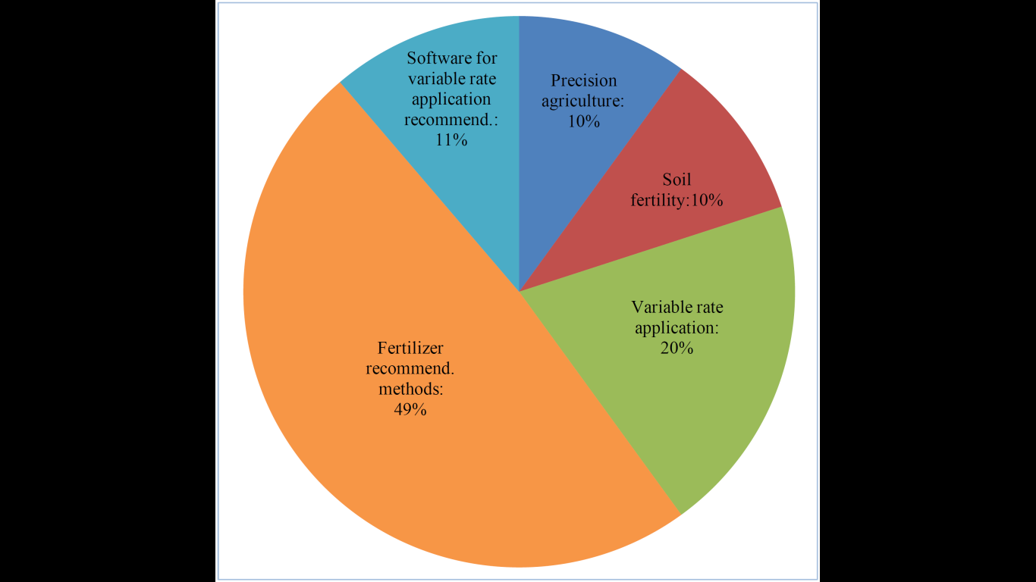

**Distribution of studies by study domain.**

**Domain Study references**

**Precision agriculture (Ayoubi et al., 2012; Lambert et al., 2007; Robert, 2002; Sapkota et al., 2014; Schirrmann & Domsch, 2011; van Raij et al., 2002; Verhagen et al., 1995; Verhagen, 1997)**

**Soil fertility (Chen et al., 2009; Frogbrook et al., 2006; Goulding, 2016; Molin et al., 2010; Schnug et al., 1998; Shukla et al., 2017; Wood & Litterick, 2017; Ziadi et al., 2013)**

**Site-specific application (Atherton et al., 1999; Basso et al., 2007; Beckie et al., 1997; Bullock & Lowenberg‐ DeBoer, 2007; Devkota et al., 2016; Haneklaus & Schnug, 2000; Jin & Jiang, 2002; Kahabka et al., 2004; Khanna et al., 2000; Lambert et al., 2007; Meyer-Aurich et al., 2010; Molin et al., 2010; Nogara Neto et al., 2011; Robertson et al., 2012; Schnug et al., 1998; Stępień et al., 2013)**

**Fertilizer recommendation methods (Adams et al., 2000; Amaral & Molin, 2011; Arregui et al., 2006; Beckie et al., 1997; Buresh et al., 2010; Coelho et al., 1992; Colaço & Molin, 2017; Csathó et al., 2009; Dinnes et al., 2002; Elprince, 2009; Francis et al., 1993; Hinsinger, 2001; Hoeft & Peck, 1998; Kersebaum et al., 2005; Lambert et al., 2007; Liu et al., 2006; B.-L. Ma et al., 2014; B. L. Ma et al., 2010; Martha et al., 2004; Olfs et al., 2005; Omafra, 2005; Pierce & Nowak, 1999; Rajsic & Weersink, 2008; Raun et al., 2002; Raun & Johnson, 1999; Rehm et al., 2006; Shanahan et al., 2008; Shapiro et al., 2008; Silva & Raij, 1999; van Es et al., 2005; van Raij, 1983; Wong et al., 2001; Xu et al., 2014, 2017; Ziadi et al., 2012)**

**INTERPRETATION**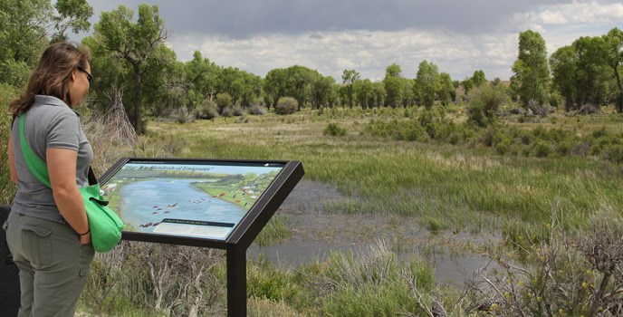

**The core strategy of this project is to predict the crop based on the soil nutrient content and the location where the crop is growing.**

**This system will help the farmers to choose the right crop for their land and to give the suitable amount of fertilizer to produce the maximum yield.**

**The Support Vector Machine algorithm helps to predict the crop precisely based on the pre-processed crop data.  
 This system will also help the newcomers to choose the crop which will grow in their area and produce them a good profit. A decent amount of profit will attract more people towards agriculture.**

**Also, the crop growth is based on the climate conditions in the particular area and the seasonal monsoons that happen now are unpredictable, hence it is easy for the farmers when the prediction result is also based on the climatic conditions. Live weather prediction will also help the users to predict the crop water needs and also it will help the farmers to decrease the crop damage due to the rain or drought.**